ALERT: BE WELL PREPARED & ALL THE BEST FOR THE MILESTONE OLYMPIAD [MSO-E.ST ] on 30-08- 2019; Friday. Good Luck!
Class I E.St. 4QsAD – 22nd August 2019; Thursday :
1. Which among these does not live in the jungle?
i. Fox ii. Lion iii. Bear iv. Cow
2. What is the colour of the sky?
i. Yellow ii. Blue iii. Brown iv. White

3. Which animal barks? ___________________

4. Which among the following is not made by man?
i. Roads ii. Stars iii. Bridges iv. Buildings
****************************************************************

ALERT: BE WELL PREPARED & ALL THE BEST FOR THE MILESTONE OLYMPIAD [MSO-E.ST] on 30-08- 2019; Friday. Good Luck!
Class II E.St. 4QsAD – 22nd August 2019; Thursday :
1. Name the place where people go to read and issue books to read?
i. Hospital ii. Mall iii. Post-Office iv. Library
2. Which among the following pairs is incorrect?
i. Shoes- Socks ii. Cup-Saucer
iii. Box- Book iv. Skirt- Blouse
3. What do we do with our nose?
i. Breathe and Smell ii. Bite and Chew
iii. Taste and Talk iv. Listen and hear
4. Which among the following is usually not found in a house?
i. living room and veranda ii. club and swimming-pool
iii. kitchen and dining room iv. bedroom and washroom

ALERT: BE WELL PREPARED & ALL THE BEST FOR THE MILESTONE OLYMPIAD [MSO- SCIENCE] on 30-08- 2019; Friday. Good Luck!
Class III Science 2QsAD – 22nd August 2019; Thursday :
1. State ‘True’ or ‘False’
i. The Earth revolves around the Sun and rotates on its tilted axis. _______
ii. Ostriches do not lay eggs; they give birth to live young ones. ________

2. What is common with an elephant and a tree?
i. both are plants ii. both are animals
iii. both have a trunk iv. both have tusks
********************************************************************************************

ALERT: BE WELL PREPARED & ALL THE BEST FOR THE MILESTONE OLYMPIAD [MSO- SCIENCE] on 30-08- 2019; Friday. Good Luck!
Class IV Science 2QsAD – 22nd August 2019; Thursday :
1. Which among the following units of measurements is an incorrect pair?
i. liquids = litres ii. solids = centimetres
iii temperature = degrees Celsius iv. Distances= Kilometres

2. State whether the following statements are ‘true’ or ‘false’
i. The Earth pulls all objects towards itself. This force of pull is known as Gravity. _____
ii. We use Dettol or Savlon; antibiotics to clean cuts and wounds. _______
*****************************************************************

ALERT: BE WELL PREPARED & ALL THE BEST FOR THE MILESTONE OLYMPIAD [MSO- SCIENCE] on 30-08- 2019; Friday. Good Luck!
Class V Science 2QsAD – 22nd August 2019; Thursday :
1. Which among the following are not found in Science Labs?
i. beakers, measuring cylinders and jars
ii. first-aid box and thermometer
iii. test tubes, slides, chemicals, and instruments.
iv skipping-rope and dumbbells

2. Name four Indian Scientists and their field of study?
i. _____________________________ ii. __________________________
iii. ______________________________. iv ___________________________
****************************************************************
ALERT: BE WELL PREPARED & ALL THE BEST FOR THE MILESTONE OLYMPIAD [MSO- SCIENCE] on 30-08- 2019; Friday. Good Luck!
Class VI Science 2QsAD – 22nd August 2019; Thursday :
1. The largest planet in the solar system is the:
[Earth / Saturn / Mars / Jupiter / Mercury]

2. The plants that cannot manufacture their own food and depend on dead and decaying organisms are:
[moulds and mushrooms / algae / mosses / ferns / palm trees]
****************************************************************

ALERT: BE WELL PREPARED & ALL THE BEST FOR THE MILESTONE OLYMPIAD [MSO- SCIENCE] on 30-08- 2019; Friday. Good Luck!
Class VII Science 2QsAD – 22nd August 2019; Thursday :
1. The Boiling Point of Water ___________
and the Melting Point of Ice is ___________

2. Which among the following is not a mineral acid?
i. Hydrochloric acid ( ) ii. Citric Acid ( )
iii. Sulphuric acid ( ) iv. Nitric acid ( )

****************************************************************

ALERT: BE WELL PREPARED & ALL THE BEST FOR THE MILESTONE OLYMPIAD [MSO- SCIENCE] on 30-08- 2019; Friday. Good Luck!
Class VIII Science 2QsAD – 22nd August 2019; Thursday :
19 Which among the following is an animal product?
{silk-cotton, cotton, silk, jute}

20. Which among the following is not a pest?
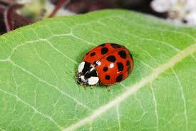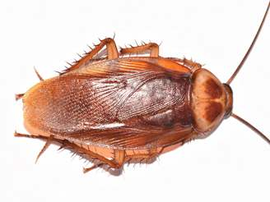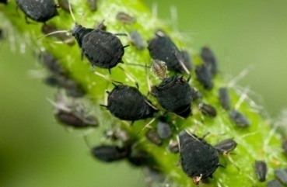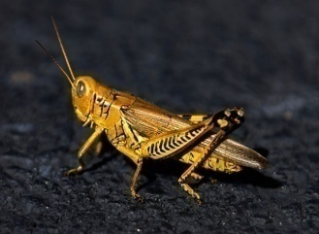
ladybird- beetle cockroach aphids locust

****************************************************************
ALERT: BE WELL PREPARED & ALL THE BEST FOR THE MILESTONE OLYMPIAD [MSO- SCIENCE] on 30-08- 2019; Friday. Good Luck!
Class IX Science 2QsAD – 22nd August 2019; Thursday :
1. Distinguish between a PHYSICIST and a PHYSICIAN _______________________________________________________________
________________________________________________________________
2. Distinguish between ORTHOPAEDICS and PAEDIATRICS? ________________________________________________________________
________________________________________________________________

****************************************************************

ALERT: BE WELL PREPARED & ALL THE BEST FOR THE MILESTONE OLYMPIAD [MSO- SCIENCE] on 30-08- 2019; Friday. Good Luck!
Class X Science 2QsAD – 22nd August 2019; Thursday :
1. Find the odd one out in the series:
a. Vernier Calipers, Screw Gauge, Measuring Cylinder,
Metre-Scale, Foot-ruler
b. Methyl Orange, Alcohol, Safranine, Aniline, Indigo

2. Which Island Continent is in the Southern Hemisphere of the World?
a. Sri Lanka [ ] b. Greenland [ ] c. Australia [ ] d. British Isles [ ]

****************************************************************
ALERT: BE WELL PREPARED & ALL THE BEST FOR THE MILESTONE OLYMPIAD [MSO- SCIENCE] on 30-08- 2019; Friday. Good Luck!
Class XI Science 2QsAD – 22nd August 2019; Thursday :
1. James Elliot is said to have discovered in 1977 the rings around this planet. Which planet are we talking about?
a. Uranus [ ] b. Jupiter [ ]
c. Saturn [ ] d. Pluto [ ]
2. In 1901 Key Maybach and Emil Jelinek ushered in a new era of automobiles. The latter had stencilled his daughter’s name in one of the kinds of automobile cars. Which car are we talking about?
a. Ford [ ] b. Morris Minor [ ]
c. Plymouth [ ] d. Mercedes [ ]
****************************************************************
ALERT: BE WELL PREPARED & ALL THE BEST FOR THE MILESTONE OLYMPIAD [MSO- SCIENCE] on 30-08- 2019; Friday. Good Luck!
Class XII Science 2QsAD – 22nd August 2019; Thursday :
1. Douglas Ring and Rae Young, way back in 1947 paved the way for invention of the ___________________ which gradually made it convenient for people to move about while speaking over the phone.
a. phonogram [ ] b. cell-phone [ ] c. RADAR [ ] d. SONAR [ ]

2. “The merchant of death is dead”. These are the words of a French newspaper’s obituary on Alfred Nobel of Sweden. What is this Swedish scientist attributed to have discovered?
a. Dynamite and Gelignite [ ] b. Bleaching Powder [ ]
c. Laughing Gas [ ] d. Ammonia [ ]
****************************************************************

